**Northeastern University Seattle campus 飞跃手册 v1.0**

全文主要分为以下衣食住行， 课程设置找工板块(in progress), 选课板块（pending）

**衣：**

outlet: 买衣服的话北边开车20分钟有outlet（奥特莱斯）基本上阿迪，耐克的店家都有，各种衣服也可以买的到。

Bellevue mall: 中心有mall也可以买到很多衣服，target本身也卖基础的一些衣服。

Target:Northgate, downtown都有target里面有基本的衣服

**食：**

学校附近有很多亚马逊的餐车，225对面有flying fish中餐， 餐车推荐小同云味道卤肉饭。 学校附近走路可以到curry of tokyo有日本咖喱，还有miao sushi 日本bento

饭店的话：

***自助：***

Feast Buffet: 485 Renton Center Way SW, Renton, WA 98057

Haiku Sushi & Seafood Buffet: 7548 164th Ave NE, Redmond, WA 98052

Mandarin Buffet & Grill: 14850 NE 24th St, Redmond, WA 98052

bluefin buffet: 401 NE Northgate Way #463, Seattle, WA 98125

***广式早茶：***

**美味来香港茶餐厅 |**Hongkong Bistro: 507 Maynard Ave S #511C, Seattle, WA 98104

Top Gun Seafood Restaurant：12450 SE 38th St, Bellevue, WA 98006

**利苑 | Fortune Garden:** 424 Maynard Ave S, Seattle, WA 98104 | (206) 521-8933

**翠苑酒家 | Jade Garden :** 424 7th Ave S, Seattle, WA 98104 | (206) 622-8181

**半岛早茶 | Top Gun Seafood Restaurant** 12450 SE 38th St, Bellevue, WA 98006 | (425) 641-3386

***火锅：***

小肥羊Little Sheep Mongolian Hot Pot: 609 S Weller St, Seattle, WA 98104

**蓉城老火锅 | Chengdu Memory:** 520 S Jackson St, Seattle, WA 98104 |（206）624-6289

**老码头四川火锅 | Sichuan Hot Pot:** 4741 12th Ave NE, Seattle, WA 98105 | (206)420-7167

**沸点 | Boiling Pot:** 1075 Bellevue Way NE, Bellevue, WA 98004 | (425)455-8375

**刘一手 | Liuyishou Hotpot**

1644 140th Ave NE, Bellevue, WA 98005 |(425) 643-9050

**豆捞坊 | The Dolar Shop:** 11020 NE 6th St #90, Bellevue, WA 98004 | (425)390-8888

***川菜：***

天府春秋 Tian Fu：300 NE Northgate Way, Seattle, WA 98125

香锅大王**Sizzling Pot King：** 660 S King St, Seattle, WA 98104 | (206) 624-0314

**诸葛烤鱼 | Szechuan Fish:** 900 S Jackson St, Seattle, WA 98104 | (206)623-3927

**锦绣成都 | Spicy City**8461 164th Ave NE, Redmond, WA 98052 | (425)896-7058

**洞庭春 | Dong Ting Chun**7425 166th Ave NE, Redmond, WA 98052 | (425) 882-7311

***面食：***

**鼎泰丰 | Din Tai Fung**

2621 NE 46th St, Seattle, WA 98105 | (206)525-0958

700 Bellevue Way NE, Bellevue, WA 98004| (425) 698-1095

**面贴面 | Dough Zone**

504 5th Ave S, Seattle, WA 98104 | (206)285-9999

815 Pine St, Seattle, WA 98101 | (206) 682-6666

15920 NE 8th St #3, Bellevue, WA 98008 | (425) 641-8000

14625 NE 24th St, Bellevue, WA 98007 | (425) 641-5555

**牛一嘴 | Nuodle**

14603 NE 20th St, Bellevue, WA 98007 | (425) 395-9999

***烧烤：***

**茉莉 | Jasmine's Grill and Bar:** 1043 S Jackson St Ste 101B, Seattle, WA 98104 | (206) 323-6666

***东北菜：***

**小达可 | Little Duck:** 4100 Roosevelt Way NE, Seattle, WA 98105 | (206) 695-2544

***北京菜：***

**御膳 | Yu Shan Chinese Restaurant**: 14553 Bothell Way NE, Seattle, WA n98155 | (206) 363-5481

***甜点奶茶：***

**黑丸 | Black Ball** 651 S King St Seattle, WA 98104 | (206) 538-0596

**鲜芋仙 | Meet Fresh** 15530 Lake Hills Blvd, Bellevue,WA 98007 | (425) 449-8748

**许留山 | Hui Lau Shan** 15120 NE 24th St Ste F, Redmond, WA 98052 | (425) 449-8885

以上内容大部分截取“西雅图吃货小分队” https://mp.weixin.qq.com/s/rQF58tD9ZZatMv22lAtSqA

**住：**

学校附近走路10分钟之内的公寓有：

Boxcar

Radius SLU

Cascade Apartments

Alcyone Apartments

Chroma SLU

AMLI 535

AMLI SLU

Modera SLU

Kiara

Stack House Apartments

Sitka Apartments

Yale624

Alley24 Apartments

Union Bay

价格1b1b 1700~2600, 2b2b 2800~4000, 10月份和4月份一般价格会低点，8~9月价格最高。月初价格低，月末价格高

**行：**

西雅图公交包月卡100刀,叫做orcas card，不包月单次2刀~2.75刀

驾照很好考，也可以找教练300到500刀左右考了之后买车

**邮寄：**

百佳有天翼快递

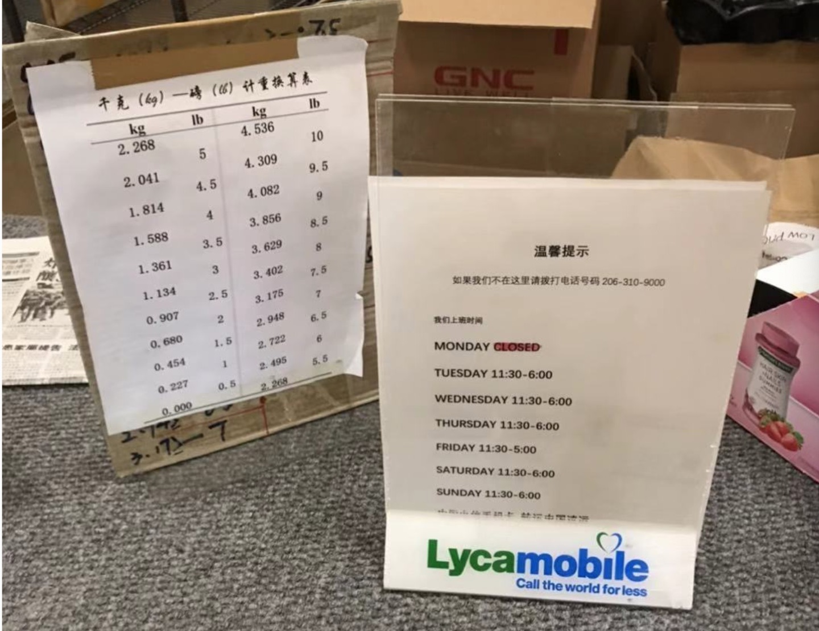

**NEU office hour drop in time**

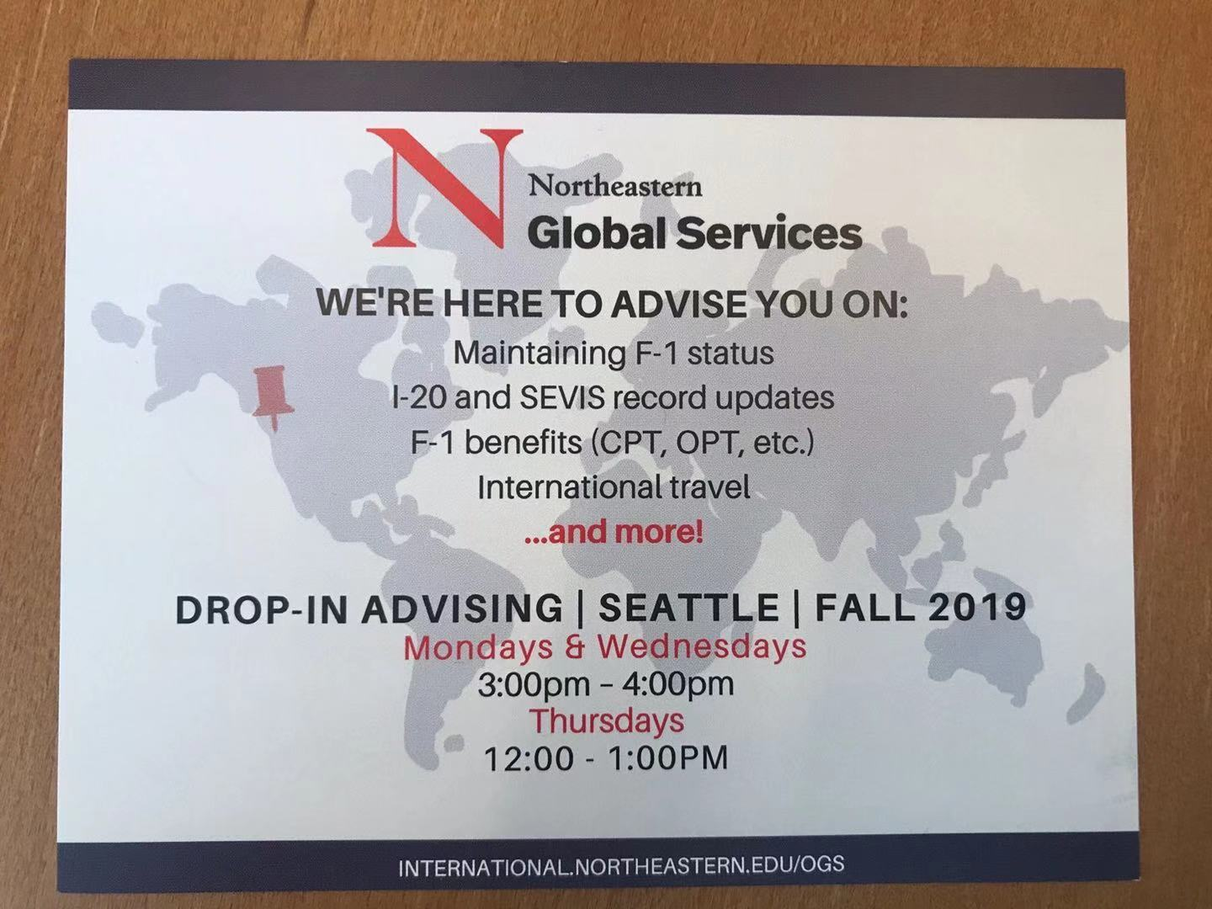

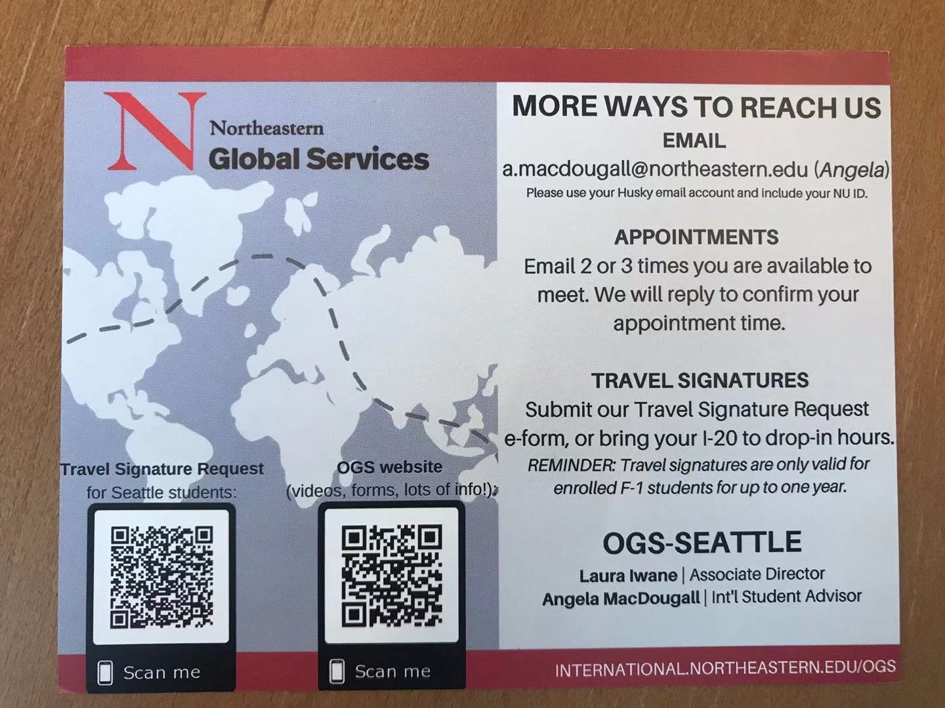

关于Align的课程设置

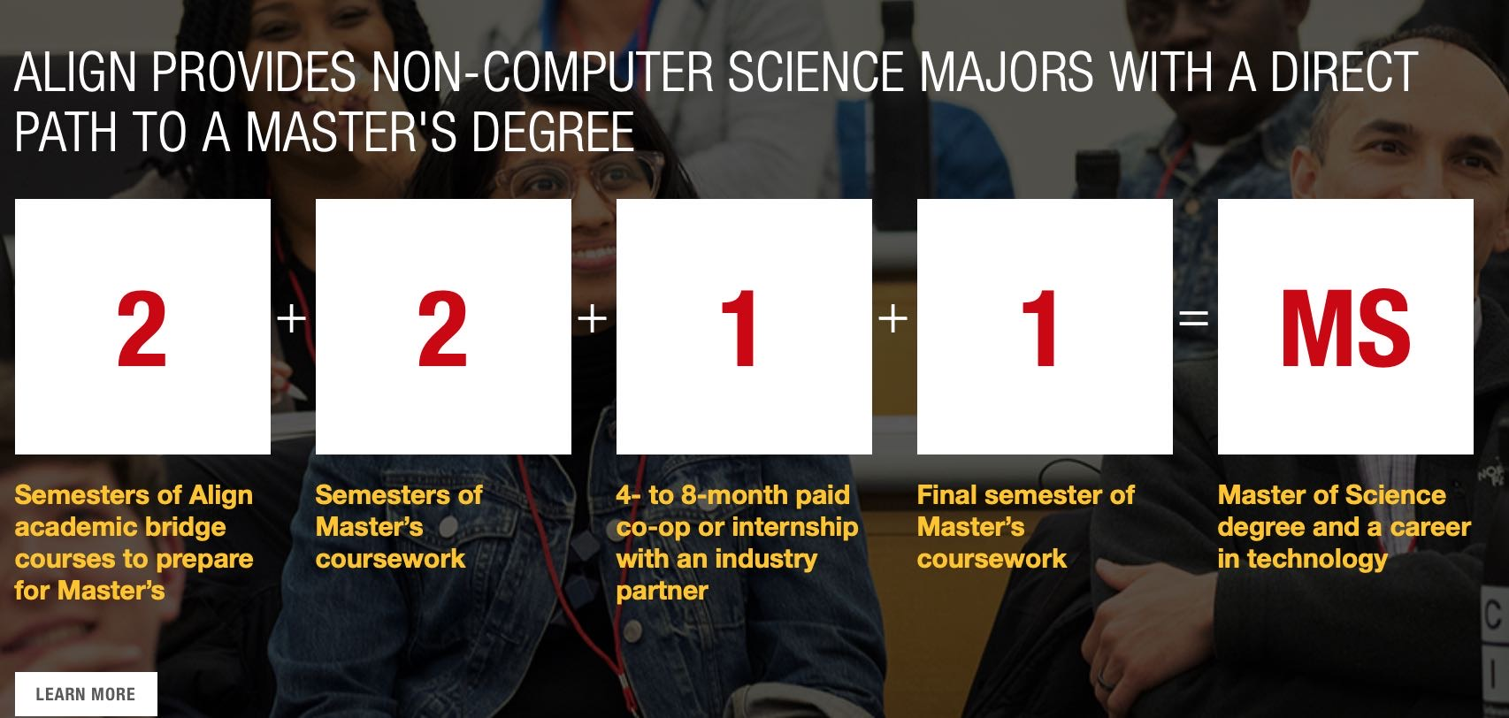

一共11门课，3门基础课，8门研究生课程，理论上4个学期之后可以实习，实际上2个学期后有flag offer一般也不会卡人。Align可以做多份实习，最多4个总时间不超过1年，IS可以做1个实习可以直接做6~8个月。

在西雅图的IT公司

Facebook

Amazon

Google

Microsoft

Concur

Expedia

Salesforce

F5 Networks

Nordstrom

Tableau

Zillow

whitepages

Uber

ReachNow

Yelp

CDK Global

Visa

**选课板块**（under construction）

Align:

Is:

PM:

Analytic:

==============================鸣谢列表================================

古城，面面（提供饭店info）